Final Examination
World Studies II

SOLs 15-1

- The Cold War is
  - A series of bloody battles between the United States and the Soviet Union.
  - A series of bloody battles between Germany and the Soviet Union.
  - A period of tension between the United States and Soviet Union with no actual fighting.
  - A period of tension between Germany and the United States.

- During the Cold War, the Soviet Union was characterized by all of the following EXCEPT
  - Communism
  - Totalitarianism
  - Socialism
  - Capitalism

- During the Cold War, the United States was characterized by all of the following EXCEPT
  - Democracy
  - Socialism
  - Capitalism
  - Individual Freedom

- The United States’ Cold War policy of the containment of communism is called
  - The Monroe Doctrine
  - The Truman Doctrine
  - The Marshall Plan
  - The NATO Plan

- The United States’ policy of the containment of communism brought the country into all of the following conflicts EXCEPT
  - World War II
  - The Korean War
  - The Vietnam War
  - The Cuban Missile Crisis

- All of the following are true of NATO EXCEPT
  - It is the North Atlantic Treaty Organization
  - It is made up mostly of western European countries
  - It is made up mostly of eastern European countries.
  - The purpose was to prevent the spread of communism

For Eddie, a blue-collar kid from South Boston who went to war to “kill a Commie. . .,”this was not the way it was supposed to be. Like countless other teenagers, Eddie felt as invincible as John Wayne.

- The excerpt above explains how many young people in America felt about the Vietnam War. They felt the war was
  - Not for them
  - Glamorous
  - Wrong
  - Ordained by God

- The United States supported South Vietnam because
  - They had close economic ties.
  - The Truman Doctrine dictated involvement in the South Vietnamese struggle.
  - The Marshall Plan offered help to the South Vietnamese.
  - There were many South Vietnamese living in America who demanded that the military provide help to their homeland.

- All of the following are true of the Cold War EXCEPT
  - It was a nuclear war between the U.S. and the U.S.S.R.
  - It was a period of high tension between the U.S. and the U.S.S.R.
  - It was a conflict between democracy and communism.
  - It lasted from the end of World War II to 1989.

- This man proposed a plan to help Europe rebuild economically after World War II.
  - Harry S. Truman
  - Nikita Khrushchev
  - Dwight D. Eisenhower
  - George C. Marshall

- A military alliance formed by the United States and other democratic nations in 1949 is called
  - COMECON
  - OPEC
  - NATO
  - Warsaw Pact

- The Truman Doctrine stated that
  - The United States will give $13 billion to Europe
  - The United Sates will try to contain communism
  - The United States will join NATO
  - Great Britain should do more in its occupation of East Germany
- All of the following is true of the Korean War EXCEPT
  - North Korea tried to exert communist rule over South Korea
  - The conflict was unsuccessful in staving off communist government in South Korea
  - The U.S. stepped in on the side of South Korea
  - The war ended in stalemate.

- The incident in which the U.S.S.R. positioned nuclear missiles on an island very close to the U.S. is called the
  - Nuclear Missile Crisis
  - Key West Crisis
  - The Cold War Crisis
  - The Cuban Missile Crisis

- All of the following are true of the division in Germany EXCEPT
  - Great Britain occupied the northwest section of Germany
  - Berlin was in the French quarter of Germany
  - Poland is east of Germany
  - The United States’ quarter of Germany bordered Austria and Czechoslovakia

- The Iron Curtain is the
  - Figure of speech which signifies the division between democracy and communism in Europe.
  - Dividing line between North and South Korea
  - Dividing line between North and South Vietnam
  - New terminology of the European Union

- What role did nuclear weapons play during the Cold War?
  - Nuclear weapons were not important during the Cold War.
  - Nuclear weapons were used to end the Cold War.
  - The build-up of nuclear weapons by the U.S. and U.S.S.R. was a key point of the Cold War.
  - The U.S. was upset that it did not have nuclear weapons, while the U.S.S.R. did.

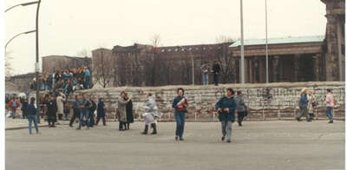
- The photograph above depicts a wall that, during the Cold War, divided a city in half. The wall divided
  - East Germany from West Germany
  - North Korea from South Korea
  - East Berlin from West Berlin
  - East Cuba from West Cuba

- All of the following would be considered causes of African Independence movements EXCEPT
  - Pride in African cultures and heritage
  - Resentment toward imperial rule and economic exploitation
  - The establishment of the mandate system by the League of Nations
  - The loss of colonies by European countries

- What is the capital of the People’s Republic of China?
  - Taiwan
  - Hong Kong
  - Beijing
  - Tiananmen’s Square

- China’s 1958 economic plan was called
  - The Great Leap forward
  - The Great Ecnomic Package
  - The Great Wall of China
  - The 1958 Plan

- What was the outcome of China’s 1958 economic plan?
  - The country flourished.
  - The people loved it.
  - Millions of people moved to the Soviet Union
  - Millions of people starved to death

- The Dalai Lama is the spiritual leader of this mountainous region
  - India
  - Pakistan
  - China
  - Tibet

- This man led a non-violent protest in India, helping to gain Indian independence from its colonial rulers.
  - Mohandas Gandhi
  - Jewerhalar Nehru
  - Fidel Castro
  - Dalai Lama

- Algeria fought for its independence from which of the following countries?
  - France
  - Great Britain
  - Portugal
  - Luxembourg

- ______________ led the Kenyan people to freedom.
  - Nelson Mandela
  - Mohandas Gandhi
  - Jomo Kenyatta
  - Dr. Martin Luther King, Jr.

- Mandates were established by
  - The United Nations after World War I
  - The United Nations after World War II
  - The League of Nations after World War I
  - The League of Nations after World War II

- All of the following were once mandates of France EXCEPT
  - Syria
  - Lebanon
  - Palestine

- Choose the BEST answer. The consequences of the Cold War were
  - Militarism, technological advances, and ideological differences between the U.S. and the U.S.S.R.
  - Heightened Patriotism, technological advances, and a rivalry between the U.S. and U.S.S.R.
  - Militarism, technological advances, and environmental damage
  - Technological advances, environmental damage, and foreign policy differences.

- Who is at conflict in the Middle East?
  - Muslims
  - Hindus
  - Jews
  - Both A & B
  - Both A & C

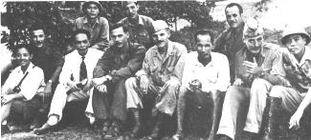
- Who is PROBABLY depicted in the above photograph?
  - North Vietnamese and South Vietnamese friends
  - North Vietnamese military leaders and members of the U.N.
  - South Vietnamese military leaders and members of U.S. forces.
  - Members of U.S. forces and Soviet diplomats

- Which of the following terms refers to Hitler’s attempt to exterminate the Jewish people?
- Inquisition
- Atheism
- Holocaust
- Great Purge

- Hitler, Stalin, Mussolini, and Hirohito are all examples of which type of leader?
- Totalitarian
- Fascist
- Communist
- Democratic

- Due to Mussolini’s desire to restore the “glory of Rome,” he led his country in an attempt to
- Attack Poland
- Imperialize Germany
- Overthrow the USSR
- Invade North Africa

- As a result of World War I, America adopted a foreign policy of
- Isolation and neutrality
- Communism and collectivization
- Pursuit and aggression
- Persecution and oppression

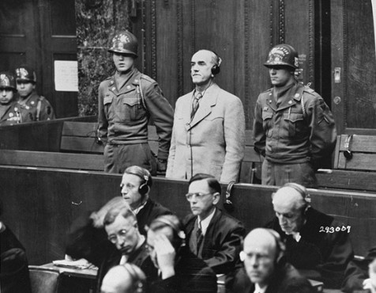
- The above picture depicts
- Jewish imprisonment during World War II.
- The Nuremberg Trials that occurred after World War II for war crimes committed.
- German officer receiving a medal of honor.
- Woodrow Wilson standing up for the League of Nations

- All of the following occurred at Yalta EXCEPT
- Germany was divided into four sections
- The formations of the United Nations began
- Hirohito and Japan surrendered to the United States.
- The Soviets gained control of Eastern Europe.

- The Nazi-Soviet Non-Aggression Pact was
- An agreement between Germany and the USSR not to fight each other.
- A sign of friendship and peace throughout the Pacific
- An agreement between Germany and France to divide France
- The beginning of the two superpowers that dominated the later part of the 20th century.

- Hitler’s “final solution” called for the
- Japanese to imperialize Manchuria
- Soviet Union to join the Axis Powers
- Extermination of all Jews
- Italians to invade Ethiopia

- What is the significance of the Japanese attack on Pearl Harbor?
- It made the Japanese Navy #1 in the world.
- It convinced the US and Britain to surrender to Germany
- It scared China and the Soviet Union into submitting to the Japanese Emperor.
- It brought the US into the war.

- V-E Day symbolized the
- Victory for the Allies in Europe
- French surrender of Czechoslovakia
- Violent overthrow of the Soviets
- Victory for the Axis in Europe

- The nations that emerged as superpowers at the end of World War II were
- The Soviet Union and United States
- France and Great Britain
- Italy and Germany
- Japan and Germany

- As a result of World War II
- Germany gained back land it lost in Russia
- Britain released its hold on many of their foreign colonies
- Japan suffered very little casualties
- Mussolini came to power in Yugoslavia

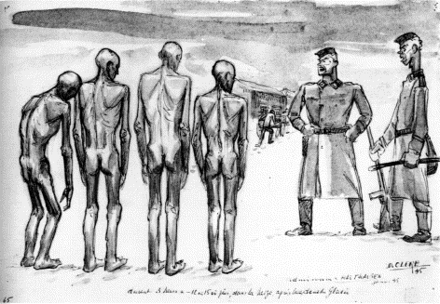
- The picture above depicts
- United States POW’s in Japanese camps
- Soviet citizens during the Great Purge
- Jews in a concentration camp
- Allied soldiers in a German POW camp

- President Truman’s reason for ordering the atomic bomb was
- To avoid having to invade Japan
- To keep the Soviet Union out of Japan
- To end Germany’s alliance with Japan
- To build up America’s economy after the Stock Market Crash of 1929

- The Marshall plan purposed that the United States
- Attack the Soviet Union to fight communism
- Require that Germany pay war reparations for the damage it caused in World War II.
- Offer economic aid to European countries trying to recover from World War II.
- Drop the atomic bomb on Japan

- The best definition of appeasement is
- Deliberate destruction of a group of people
- Giving into the demands of an aggressor in order to keep the peace.
- A state of tension and hostility among nations without armed conflict
- A form of government which is based on extreme nationalism

- Hitler claims that due to Germany’s increasing population, his country needs more
- Liverwurst
- Lebensraum
- Appeasement
- Anarchy
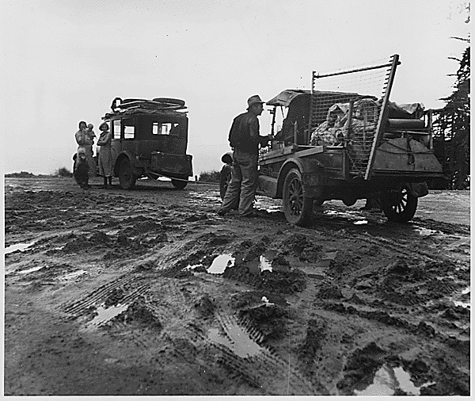
- The photo above shows
- German soldiers moving in to France.
- The relocation of European Jews
- The migration of American farmers during the Dust Bowl.
- Conditions in Japan after the US dropped two atomic bombs

Use the map below to answer the questions that follow.

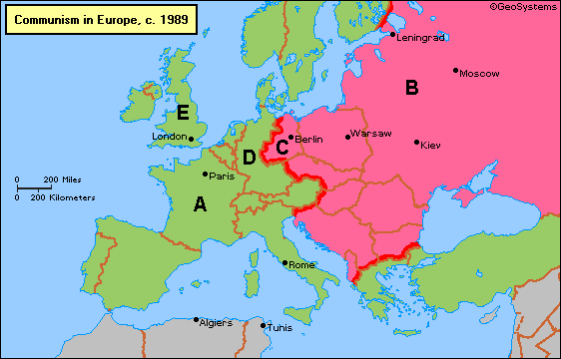

- Countries that are darkly shaded represent countries with what type of government?
- Democratic
- Communist
- Socialist
- Ultranationalist

- Countries that are lightly shaded represent countries with what type of government?
- Democratic
- Communist
- Fascist
- Secret

- The dark line down the middle of the map could represent what figurative object?
- The Berlin Wall
- The German Wall
- The Iron Curtain
- The Superpower League

Choose the appropriate letter for each of the following countries.
- Soviet Union
- England
- West Germany

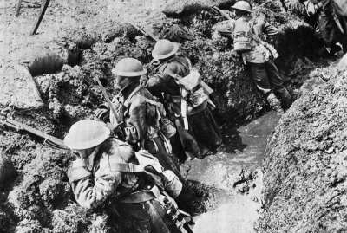

- The above picture depicts which war-time situation?
  - Submarine warfare
  - Trench warfare
  - Nuclear power
  - Tank technology

- Which of the following factors did NOT contribute to World War I?
- Militarism
- Alliances
- Imperialism
- Neutralism

- Which of the following was NOT used on the western front (of Germany)?
- Machine guns
- U-Boats (German Submarines)
- Trench warfare
- Mustard gas

- All of the following were causes of the Bolshevik Revolution of 1917 EXCEPT
- Defeat and high casualty rates of World War I
- Oppressive and ineffective rule by the Czar
- Capitalist reforms led by Stalin
- Lack of adequate food, fuel, and shelter for most people.

- The Treaty of Versailles can best be described as
- Forgiving and lenient to the Germans
- Harsh and punishing to the Germans
- Equitable and fair to the Germans
- Favorable and promising for the Germans

- Which German strategy in the North Sea threatened Allied supply lines?
- Trench warfare
- Mustard gas
- Unrestricted submarine warfare
- Airtime balloon surveillance

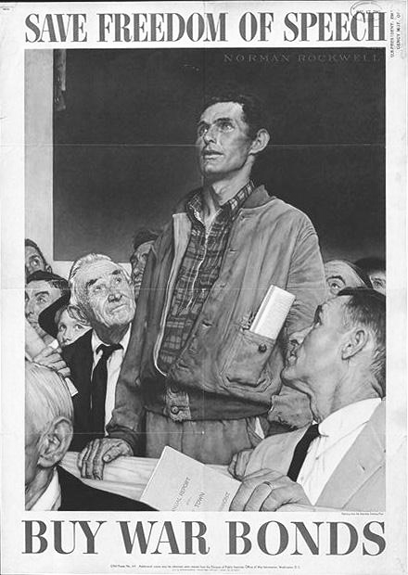
- The above poster is an example of
- Kindergarten art
- Jail penalty warnings
- Propaganda
- Imperialism

- Which of the following Peace of Paris participants is INCORRECTLY matched with his country?
- Lloyd George—Great Britain
- Orlando—Germany
- Clemenceau—France
- Wilson—USA

- The Treaty of Versailles attempted to
- Limit Germany’s size and power.
- Establish a fair and lasting peace.
- Restrict the independence of former British Colonies
- Create a buffer zone between Russia and Western Europe

- The main purpose of the League of Nations was to
- Aid postwar reconstruction
- Plan for world disarmament
- Enforce the Treaty of Versailles
- Support peace through negotiations, not war.

- The incident that marked the change in the United States’ feelings of neutrality was
- The sinking of the Lusitania
- The invasion of Belgium
- The Tannenberg Battle
- The Assassination of Archduke Frans Ferdinand

- All of the following were initial members of the League of Nations EXCEPT
- Great Britain
- France
- USA
- Poland

- The final event that drew the United States into World War I was
- The Treaty of Versailles
- The Zimmerman Note
- The Sinking of the Lusitania
- The League of Nations

Use the map below to answer the questions that follow about Cold War locations.
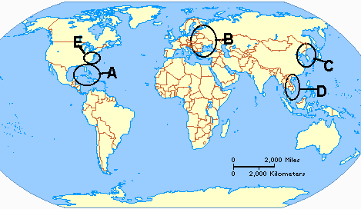
- Where was the Communist Bloc?
- Where did the Vietnam conflict take place?
- Where are we now?
- Where did the Korean conflict take place?
- Where did the Cuban Missile Crisis take place?

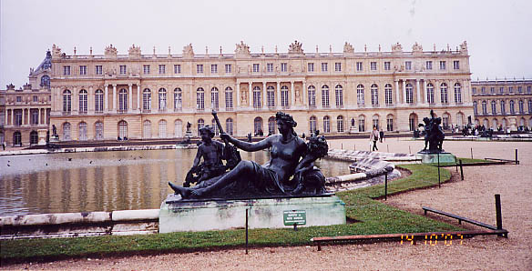
- This ruler had a magnificent palace built (shown above).
- Peter the Great
- Louis XIV
- Elizabeth I
- Catherine the Great

- The Napoleonic Code did all of the following EXCEPT
- Made French law clear and consistent.
- Rewrote laws to follow natural law.
- Made the upper classes pay 95% of the taxes.
- Put state interests above that of the individual.

- All of the following are similarities between the American and French Revolutions EXCEPT:
- Freedom documents like the Declaration of Independence.
- The Spread of democratic ideals like equality and individual liberties.
- The influence of enlightened philosophers like John Locke and Thomas Jefferson.
- Mass killing like the Reign of Terror.

- How did the philosophers of the enlightenment influence thinking on political issues?
- They fueled democratic revolutions around the world.
- They wrote books in support of divine right.
- They promoted the heliocentric theory.
- They provided material for the Protestant Reformation.

- This man is famous for his composition of fugue and counterpoint musical pieces.
  - Delacroix
  - Handel
  - Bach
  - Mozart

- How did the new theory of the universe challenge the established order?
- The scientists denounced the theory of the rotating heavenly bodies.
- The absolute monarchs condemned the idea of feudal obligations.
- The scientists defied the traditionally accepted teachings of the Christian Church.
- The enlightened vassals pardoned the nobility from all excommunication rituals.

- In the work The Social Contract, the contract is between
- The king and the nobility
- The government and the people.
- The businesses and the consumers
- The lords and the vassals

- The event in which William and Mary of Orange took over the English throne is called the
- Glorious Revolution
- Bloodless Revolution
- English Revolution
- English Bill of Rights

- This document insured the rights of individual Englishmen in 1689 and thereafter.
- The Glorious Revolution
- The English Declaration of Rights of Man
- The English Bill of Rights
- The English Constitution

- In the Leviathan, the philosopher wrote that
- The government should protect a person’s life, liberty, and property.
- The government should be separated into three branches.
- One should only obey the government if it is just and protects people’s rights.
- Life is nasty, brutish, and short and people need an absolute ruler to keep things from becoming chaotic.

- This man wrote Two Treatises on Government
- Thomas Hobbes
- Baron de Montesquieu
- Jean-Jacques Rousseau
- John Locke

- In the Declaration of Independence, the philosopher said that
- One should only obey the government if it is just and protects people’s rights.
- The government should be separated into three branches.
- The government should protect a person’s life, liberty, and property.
- The government should protect a person’s life, liberty, and pursuit of happiness.

- In The Spirit of Laws, the philosopher said that
- The government should protect a person’s life, liberty, and pursuit of happiness.
- The government should be separated into three branches.
- One should only obey the government if it is just and protects people’s rights.
- Life is nasty, brutish, and short and people need an absolute ruler to keep things from becoming chaotic.

- In Social Contract, the philosopher said that
- The government should protect a person’s life, liberty, and property.
- The government should be separated into three branches.
- One should only obey the government if it is just and protects people’s rights.
- Life is nasty, brutish, and short and people need an absolute ruler to keep things from becoming chaotic.

- The Enlightenment espoused all of the following EXCEPT
- People have a say in their government.
- Reason applies to all humans.
- Absolute Monarchs rule by Divine Right.
- There should be religious tolerance.

- This man was head of the controlling political party during the French Revolution
  - Maximillian Robespierre
  - Louis XVI
  - Marie Antoinette
  - Baron de Montesquieu

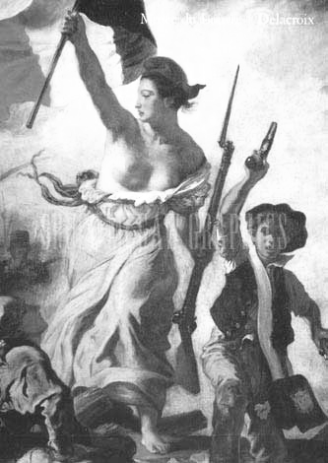
- The artist who painted the above piece is
- Cervantes
- Bach
- Delacroix
- Da Vinci

- All of the following were new techniques during the enlightenment EXCEPT
- All weather roads, which improved year-round transportation.
- New farm tool designs which increased productivity.
- Improvements in ship design which lowered the cost of transporting goods.
- The development of the submarine which gave countries with the technology a significant naval advantage.

- The above diagram depicts what theory?
- The Enlightened Theory
- The Revised Theory on Stars, Planets, and Locations
- The Heliocentric Theory
- The Scientific Theory

- Which scientist theorized (thought of) the above theory?
- Galileo Galilei
- Isaac Newton
- Nicolas Copernicus
- William Harvey

- Which scientist proved the above theory?
- Harvey
- Kepler
- Newton
- Copernicus

- Which scientist used observation to discover that blood flows through the body?
- William Harvey
- Isaac Newton
- John Locke
- William Tell

  - Which of the following terms might have been spoken by a Spanish Conquistador?
    - “Heaven, Hay, and Health!”
    - “Bribery, Bible, and Bail!”
    - “Tobacco, Torah, and Triangular Trade!”
    - “Gold, God, and Glory!”

  - The introduction of new diseases in the Americas resulted in
- Economic prosperity
- Population decrease
- Racial Harmony
- Improved medicine

  - Europeans set up colonies with the expectation that the colonies would deliver
  - Manufactured goods.
  - New economic ideas.
  - Raw materials.
  - Technological services.

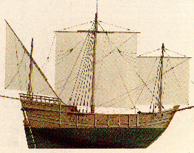
  - Ships like the one in the above photo made navigation easier with
  - Sails that could sail against the wind.
  - A shallower hull for maneuvering through shallow water.
  - A moved rudder for greater maneuvering control.
  - Both A and C.
  - All of the above.

  - The above ship is called a
- Man o’ War
- Caravel
- Cruise Ship
- Carnivale

  - The exchange of agricultural goods, livestock, and sometimes diseases between Europe and the Americas is called
- Triangular trade.
- Columbian exchange.
- Population depletion.
- Fair trade practices.

  - Bullion refers to the amount of ________________ a nation has.
- Land
- People
- Gold and Silver
- Slaves

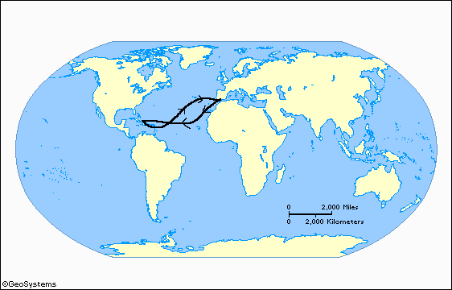

  - Who completed the journey indicated on the above map?

Cartier

Columbus

Dias

Da Gama

  - What large body of water did the explorer from the above map cross?

Mediterranean Sea

Atlantic Ocean

Pacific Ocean

Gulf of Mexico

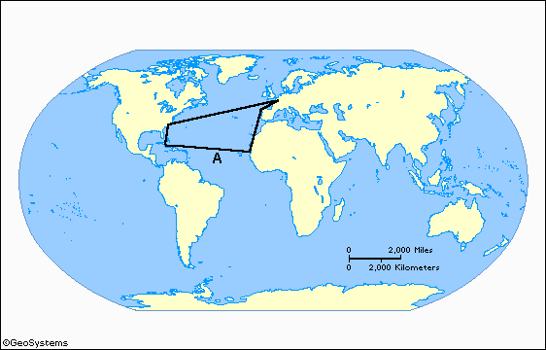
  - The map above represents what trade practice?

Slave trade

Triangular trade

The Columbian exchange

Multi-continental trade

  - The trade route labeled with an “A” is called the

Southern route

Southern Passage

Middle Passage

Route of Death

  - The main commodity traded on the route labeled with an “A” on the above map was

Slave and guns

Rum and fish

Wood and gold

Ivory and sugar cane

  - All of the following products were indigenous to Europe and brought to the Americas EXCEPT

Cattle

Horses

Rice

Smallpox

  - Francisco Pizarro’s explorations were sponsored by

Portugal

Spain

England

France

  - All of the following products were indigenous to the Americas and taken to Europe EXCEPT

Coffee

Tobacco

Potatoes

Silk

  - The act of sailing around the world is called

Circumventilation

Circumnavigation

Circumcorrelation

Superior navigation

  - The trade route between Beijing and Constantinople is commonly called the

Long Road

Road Less Traveled

Silk Road

Road of Long Journeys

  - A trade route that is Trans-Saharan crosses this continent.

Asia

Europe

North America

Africa

  - Indigenous refers to ___________ people, vegetation or culture.

Farming

Native

Wealthy

Political

  - The people that follow the Islamic faith are known as
- Israelites
- Muslims
- Protestants
- Orangemen

  - What characteristic do Pakistan and Palestine have in common?
- They are both in the Middle East.
- They are both predominantly Muslim.
- They both oppose Yasser Arafat.
- They both have a majority population of Christians.

  - This man believed in predestination
- John Calvin
- Henry VIII
- Martin Luther
- Leo X

  - This man wrote In Praise of Folly
- Michelangelo
- Da Vinci
- Erasmus
- Shakespeare

  - Renaissance means
- "do over"
- "rebirth"
- "you bet"
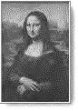
- "rich pope"

  - The above painting is entitled
- The School of Athens
- The Sistine Chapel
- A Self Portrait
- Mona Lisa

  - Which of the following artists painted the previous piece of work?
- Michelangelo
- Da Vinci
- Erasmus
- Shakespeare

  - The head of the Catholic Church is called the
- Head Priest
- Archbishop
- Your Highness
- Pope

  - Another name for the Church of England is
- Calvinist Church
- Lutheran Church
- Catholic Church
- Anglican Church

  - This man invented the printing press with moveable type
- Isaac Newton
- Johannes Gutenberg
- Johannes Kepler
- William Harvey

  - During the Renaissance, education changed from being religiously based to being
- Boring
- Required
- Secular
- Expensive

  - This man painted the ceiling of the Sistine Chapel
- Michelangelo
- Da Vinci
- Erasmus
- Shakespeare

  - This man established the Church of England
- John Calvin
- Henry VIII
- Martin Luther
- Leo X

  - The seat (head) of the Catholic Church is located in
- Venice
- Rome
- Florence
- Zurich

  - Slaves were exported from Africa on the
- North Coast
- East Coast
- West Coast
- Southern Tip

  - A member of the Society of Jesus was called
- Jesuit
- Mormon
- Priest
- Monk

  - This invention made books less expensive and eventually led to widespread literacy
- The model of the universe
- The printing press
- The Bible
- The Society of Jesus

  - This man wrote many plays about love, death, and other humanist ideas.
- Michelangelo
- Da Vinci
- Erasmus
- Shakespeare

  - This man believed in "justification by faith"
- John Calvin
- Henry VIII
- Martin Luther
- Leo X

  - The Medicis played a significant role in the Renaissance as
- Painters of everyday scenes
- Patrons of the arts
- Scientists who furthered medical research
- Military leaders

  - Humanism was a philosophy which focused on
- religious issues
- obtaining salvation
- artwork and literature
- secular (worldly) issues

  - One reason that the Renaissance began in Italy was that
- Italy had a calm atmosphere
- People in other parts of Europe were uneducated
- Wealthy Italian bankers and merchants supported the arts
- The Church controlled every aspect of life in Italy

  - In Renaissance Italy, patrons were
- Wealthy people who supported the arts
- Scholars who studied ancient arts
- Members of an Italian religious order
- Artists who painted in the style of Michelangelo

  - The religious diversity of Western Europe is mainly the result of
- The Congress of Vienna
- World War II
- The French Revolution
- The Protestant Reformation

  - The advise given to rulers in Machiavelli's The Prince was to
- Govern for the benefit of the people
- Do what is morally right
- Be honest in dealing with others
- Do whatever is necessary to gain power

  - Leonardo Da Vinci was the ideal “Renaissance man” because he was
- Successful in one particular field
- Wealthy from trade
- Well rounded in many fields
- Powerful in politics

I preached the ideas of predestination, hard work, discipline, and morality. These ideas were supported by French Huguenots and led to bloody wars during and after the Reformation.

  - The above quote could have been credited to
- John Calvin
- Thomas Aquinas
- Erasmus
- Shakespeare

When I divorce my wife, Catherine of Aragon, also divorced myself from the Roman Catholic Church and formed the Anglican Church, overthrowing the authority of the Pope in England.

  - The above quote could have been credited to
- Martin Luther
- Henry VIII
- Louis XIV
- Ivan the Terrible

  - The Protestant Reformation was an attempt to change
- Muslim Mosques
- Protestant Churches
- Jewish Synagogues
- Catholic Churches
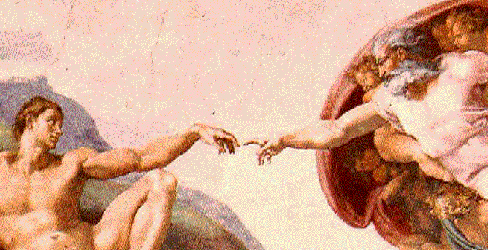

Who painted the above piece of artwork?
- Raphael
- Da Vinci
- Rembrandt
- Michelangelo

  - The artists of the Renaissance focused on
- Humans and their experience
- The spiritual world
- The universe
- The Catholic Church

  - How did King Henry react when the Pope refused to annul his marriage?
- He started a war
- He began the church of England
- He started the reformation
- He imposed fines on the Roman Catholic Church

  - Which author supported the absolute (total ) power of the monarchs?
- Shakespeare
- Erasmus
- Petrarch
- Machiavelli

  - Which of the following ideas would NOT be found in Machiavelli’s The Prince?
- Fear is more powerful than love
- Power must be kept by any means
- Do good if possible, but evil when necessary
- Make a pilgrimage to one’s holy city

  - The name of the above piece of artwork is
- The Last Supper
- The Mona Lisa
- The School of Athens
- The Introduction of Mohammad

  - The following picture is which historic monument?
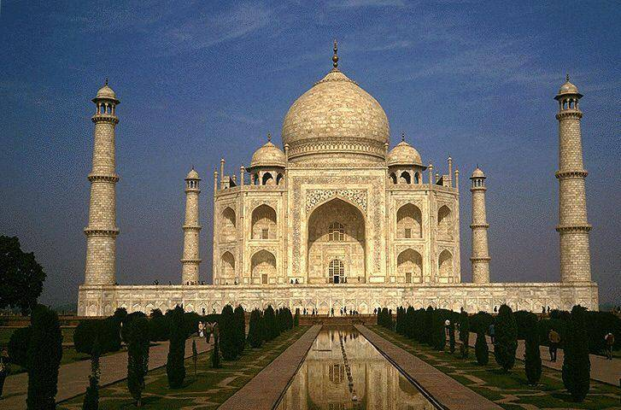
A Temple Mount
B Taj Mahal
C Ottoman Museum
D Constantinople

  - The Mughal Empire and the Ottoman Empire have which common characteristic?
A led by Genghis Khan
B Islamic religion
C located in India
D believers of jihad

  - The Ottoman Empire spans which three continents?
A China, Japan, and India
B England, France, and Germany
C Asia, America, and Afghanistan
D Africa, Europe, and Asia

  - The Ottoman Empire came to be a powerful force after the capture of which city?
A Constantinople
B Jerusalem
C Beijing
D Palestine

  - Which empire is CORRECTLY matched with the items they are known to have traded?
A Mughal – salt and gunpowder
B Ottoman – ceramics and coffee
C Japan – fish and gold
D Songhai – oil and iron

  - Who was responsible for having the Taj Mahal constructed?
A Osman I
B Aztecol
C Shah Jahan
D Qing Chang

Empires of the World
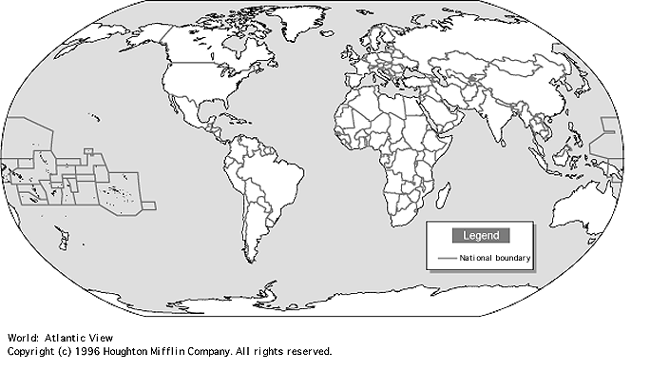
A
B
C
D

  - On the above map, which letter indicates where the Mughal Empire would have been located?
A A
B B
C C
D D

  - On the above map, which letter indicates where the Ottoman Empire would have been located?
A A
B B
C C
D D

  - On the above map, B is found on which continent?
A Asia
B Australia
C Europe
D Africa

  - Jesuit missionaries spread the word of
A Christianity
B Hinduism
C Buddhism
D Confucianism
  - Siddhartha Gautama is the founder of which religion
A Buddhism
B Hinduism
C Taoism
D Shintoism

  - Hebrew people are also known as
A Shinto
B Jews
C Muslims
D Japanese

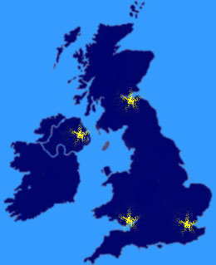

  - The above map depicts the area of conflict between
A Jew & Muslim
B Christian & Islam
C Catholic & Protestant
D Hindu & Buddhist

  - Which of the following is NOT a characteristic of Hinduism?
A caste system
B Aryan descent
C Chinese location
D polytheistic

  - Which religion respects the words of the Vedas?
A Taoism
B Shintoism
C Hinduism
D Christianity

  - The Torah is to Judaism as the Bible is to
A Christianity
B Islam
C Hinduism
D Taoism

  - The Ten Commandments are to Judaism as the Eightfold Path is to
A Shintoism
B Hinduism
C Buddhism
D Taoism

  - Which of the following religions/philosophies is INCORRECTLY matched with its region?
A Judaism – Israel
B Hinduism – India
C Buddhism – China
D Christianity – Kashmir

  - Which of the following is monotheistic?
A Islam
B Hinduism
C Buddhism
D Confucianism

  - What type of social class distinction do the Hindu practice?
A The Kostunica system
B The Caste system
C The Croatian system
D The Katmandu system

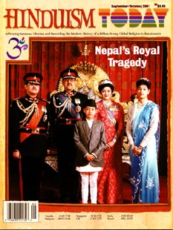

  - The above magazine cover would most likely be found in which country?
A Palestine
B India
C Egypt
D England

  - The Hindu people are descendant of the
A Albanians
B Aryans
C Assyrians
D Animists

  - Mohammad founded which religion?
A Hinduism
B Buddhism
C Judaism
D Islam

  - Which of the following is a holy city to Judaism, Christianity, and Islam?
A Mecca
B Medina
C Antioch
D Jerusalem

  - Hinduism developed first in this country:
A Russia
B India
C China
D Japan

  - The cycle of rebirth in Hinduism is known as
A reincarnation
B karma
C nirvana
D heaven

  - Upanishads and Vedas contain the stories of
A Christianity
B Judaism
C Hinduism
D Buddhism

  - Of the following groups, which one supports the rights of British citizens?
A Orangemen
B IRA
C Sinn Fein
D Hizbullah

  - Ireland is predominantly which religion?
- Protestant
- Catholic
- Hindu
- Muslim

  - Which person was the first to bring Protestantism to England?
- Henry VIII
- Oliver Cromwell
- Yasser Arafat
- A. Sharon

  - Which area caused dispute between Ireland and England?
- Northern Ireland
- Northern England
- Southern London
- Southern Lebanon

  - Ireland is on which continent?
- North America
- England
- Asia
- Europe

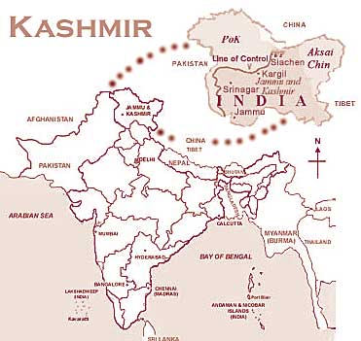

  - Of the following, the best title for the above map would be
A Problems in Palestine
B Conflict in Kashmir
C Yuck in Yugoslavia
D Trouble in Tibet

  - Ariel Sharone is the leader of
- Pakistan
- Israel
- Ireland
- Palestine

  - The former leader of Yugoslavia was
- Kostunica
- Yeltsin
- Clinton
- Milosovic

  - Which of the following is NOT an area of dispute between Israel and Palestine?
- Golan Heights
- Yugoslavia
- West Bank
- Gaza Strip

  - Israel is in which region of the world?
- North America
- Middle East
- North Europe
- South West Asia

  - Which group, led by Yasser Arafat, fights for Palestinian rights?
- PLO
- PBS
- IRA
- IRS

  - During the rule of Milosovic, his country lost the territory of
- Palestine
- Pakistan
- Bosnia
- Belgrade

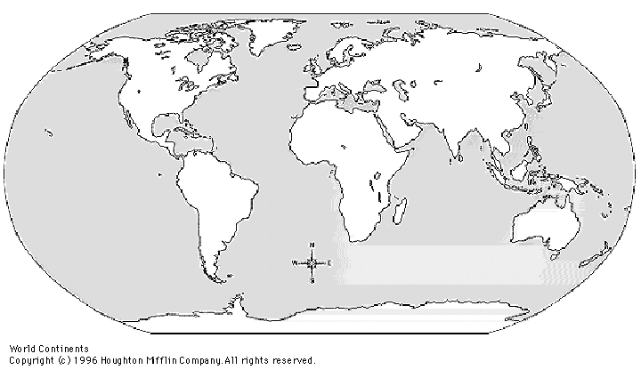
1
2
3

  - Which of the following areas is represented by the number 1?
- Ireland
- Israel
- Yugoslavia
- Kashmir
  - Which of the following areas is represented by the number 3?
- Ireland
- Israel
- Yugoslavia
- Kashmir

  - The Bible is to Christianity as the Torah is to
- Islam
- Judaism
- Hindu
- Protestant

  - Which of the following areas is mainly Muslim?
- Kosovo
- Serbia
- Bosnia
- Croatia

  - Bosnia and Palestine have what characteristic in common?
- Both are in the Middle East.
- Both are predominantly Muslim territories.
- Both areas withdrew from Yugoslavia.
- Both are ruled by Yasser Arafat.

  - Religions traditionally dispute land control in the Middle East due to claims that these areas are
- Secular territories.
- Politically unstable.
- Holy sites.
- Ruled by the Edict of Nantes.
  - The Hindu people accept the words of the
- Bible
- Koran
- Vedas
- Nirvana

  - The Muslim people follow the guidelines set out in the
- Bible
- Torah
- 10 Commandments
- 5 Pillars

  - Of the following countries, which would be found in South Asia?
- Ireland
- France
- Lebanon
- India

  - What characteristic do Pakistan and Palestine have in common?
- They are both in the Middle East.
- They are both predominantly Muslim.
- They both oppose Yasser Arafat.
- They both have a majority population of Christians.

  - Which two countries currently disagree on the exact border of Kashmir?
- Israel & Palestine
- Ireland & London
- Jerusalem & Hebron
- Pakistan & India

- Which of the following is monotheistic?
A Islam
B Hinduism
C Buddhism
D Confucianism
Short Answer--Answer SEVEN of the following questions in two or three COMPLETE sentences.

- What were the beliefs of Martin Luther?

- Who were some important explorers?

- What was the triangular trade?

- How did Africa become involved in foreign trade?

- Who were the Absolute Monarchs?

- Name one enlightened philosopher and one of his ideas.

- What was the significance of the Congress of Vienna?

- How did the Industrial Revolution affect slavery?

- What was the League of Nations and why did it fail?

- What was the U.S. policy of containment?

VII. Essay--Choose ONE of the following topics. Write an essay of at least three paragraphs of at least five sentences each.

- How did Johannes Gutenberg's invention change the world?
- What impact did Europeans have on the New World?
- What were the major causes of World War II?

